# Spring Fundamentals Exam

# My Music DB Application

Exam for the ["Spring Fundamentals" course @ SoftUni](https://softuni.bg/trainings/3222/spring-fundamentals-january-2021).

**My Music DB** **Application** is here to help us gather information about our favorite music artists and their albums. Of course, this is a lot of work, but for starters we will start with three of the most popular artists. Once we find all their albums, we will add more artists so that our application can have even more data, to help users find information about their favorite artists and tiny albums. At this stage, the functionality of the application is small, but later I believe that you could future develop it by adding many new futures.

## Database Requirements

The **Database** of the **My Music DB** application needs to support **3 entities**:

### User

* Has an **Id – UUID-string or Long**
* Has a Username (unique)
  + Username length must be between 3 and 20 characters (inclusive 3 and 20).
* Has a Full Name
  + Full Name length must be between 3 and 20 characters (inclusive 3 and 20).
* Has a Password
  + Password length must be between 5 and 20 characters (inclusive 5 and 20).
* Has an Email
  + Must contains '@'.
  + The email must be unique.

### Album

* Has an **Id – UUID-string or Long**
* Has a Name
  + Name length must be between 3 and 20 characters (inclusive 3 and 20).
* Has an Image Url
  + Image Url length must be minimum 5(inclusive) characters.
* Has a Description
  + Description min length must be minimum 5(inclusive) characters
  + The description is a long text field.
* Has a Copies
  + All sold copies of the album
  + Must be a more than 10(inclusive).
* Has a Price
  + Price must be a positive number
* Has a Release date
  + Date that cannot be in the future
* Has a Producer
  + Name of producer
  + Can be null.
* Has a Genre
  + Option between (Pop, Rock, Metal and Other).
    - This is just an enumeration, not entity.
* Has an Artist
  + Has ONLY ONE artist
  + This is the relation with artists
* Has a Added From (user)
  + A User that adds this album to the My Music DB application

### Artist

* Has an **Id** – **UUID-string or Long**
* Has a Name of the singer or the band.
  + option between (Queen, Metallica, Madonna)
* Has a Career information
  + The carrier information is a long text field.
  + This is optional, can be set to null.

**Nullable/Empty strings are not allowed unless explicitly mentioned.**

Implement the entities with the **correct datatypes** and implement **repositories** for them.

Here is the ER Diagram:

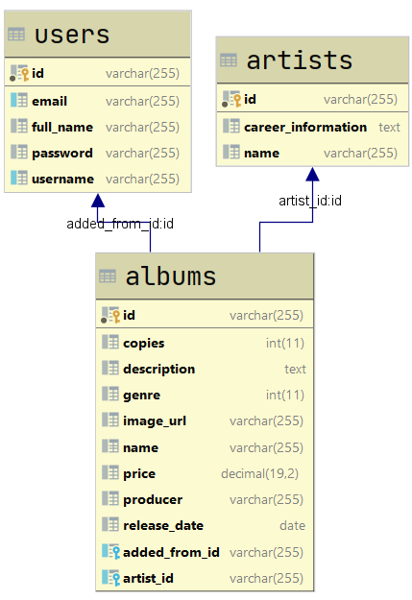

## Initialize artists

* Implement a method that checks (when app started) if the database does not have any artist and   
  initialize them
  + You are free to do this in some different ways.
  + If you want, you can skip the career information to be null or add this:
    - **Queen Career information:**
      * Queen are a British rock band formed in London in 1970. Their classic line-up was Freddie Mercury (lead vocals, piano), Brian May (guitar, vocals), Roger Taylor (drums, vocals) and John Deacon (bass). Their earliest works were influenced by progressive rock, hard rock and heavy metal, but the band gradually ventured into more conventional and radio-friendly works by incorporating further styles, such as arena rock and pop rock.
    - **Metallica Career information:**
      * Metallica is an American heavy metal band. The band was formed in 1981 in Los Angeles by vocalist/guitarist James Hetfield and drummer Lars Ulrich, and has been based in San Francisco for most of its career. The band's fast tempos, instrumentals and aggressive musicianship made them one of the founding "big four" bands of thrash metal, alongside Megadeth, Anthrax and Slayer. Metallica's current lineup comprises founding members and primary songwriters Hetfield and Ulrich, longtime lead guitarist Kirk Hammett, and bassist Robert Trujillo. Guitarist Dave Mustaine and bassists Ron McGovney, Cliff Burton and Jason Newsted are former members of the band.
    - **Madonna Career information:**
      * Madonna Louise Ciccone - born and raised in Michigan, Madonna moved to New York City in 1978 to pursue a career in modern dance. After performing as a drummer, guitarist, and vocalist in the rock bands Breakfast Club and Emmy, she rose to solo stardom with her debut studio album, Madonna (1983). She followed it with a series of successful albums, including all-time bestsellers Like a Virgin (1984) and True Blue (1986) as well as Grammy Award winners Ray of Light (1998) and Confessions on a Dance Floor (2005).

## Page Requirements

### Index Page (logged out user)

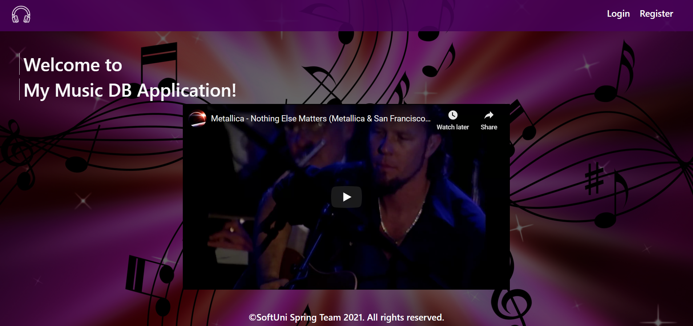

### Login Page (logged out user)

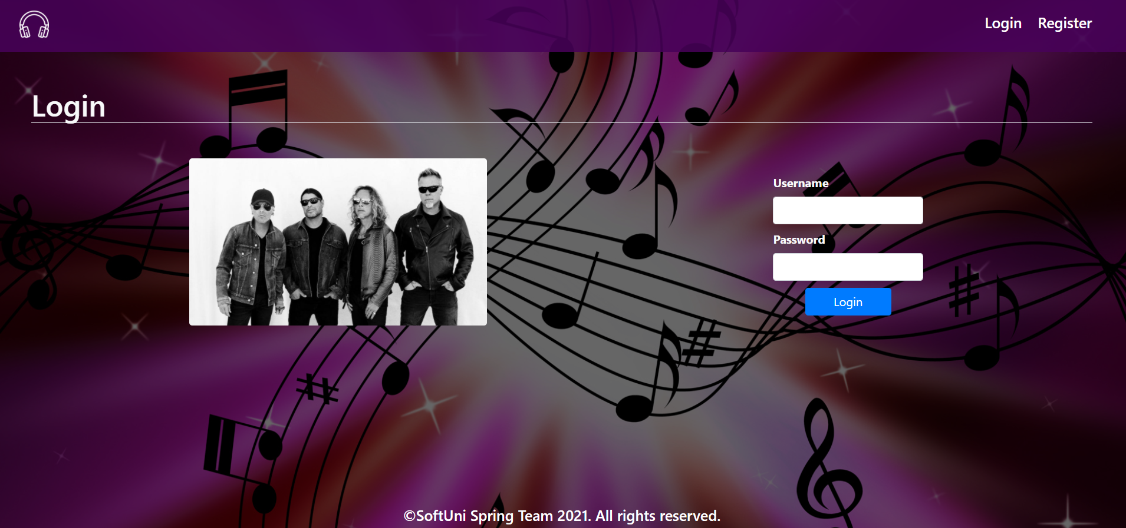

### Login Page validations

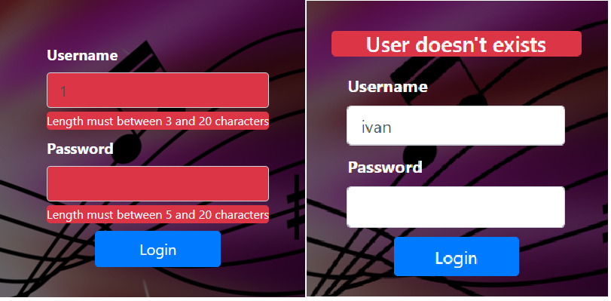

### Register Page (logged out user)

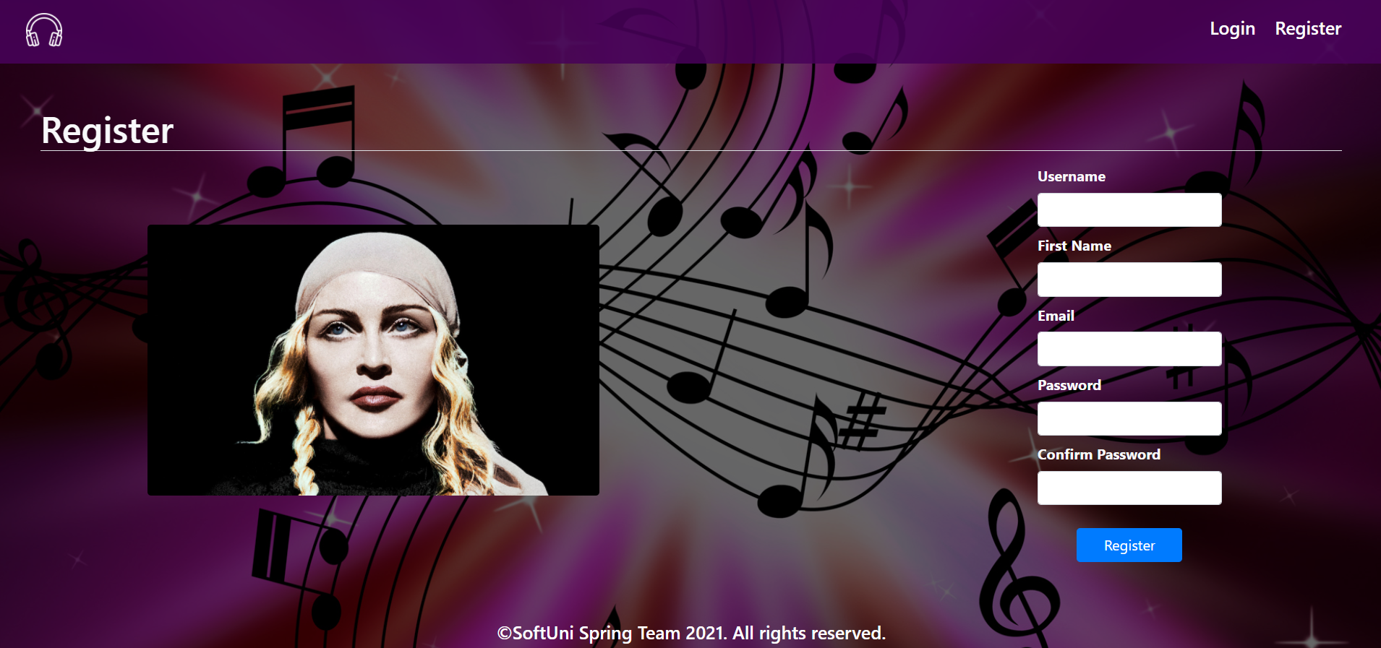

### Register Page validations

* Note: it is not necessary to show message for different passwords, just not save the user and redirect again to the register page.

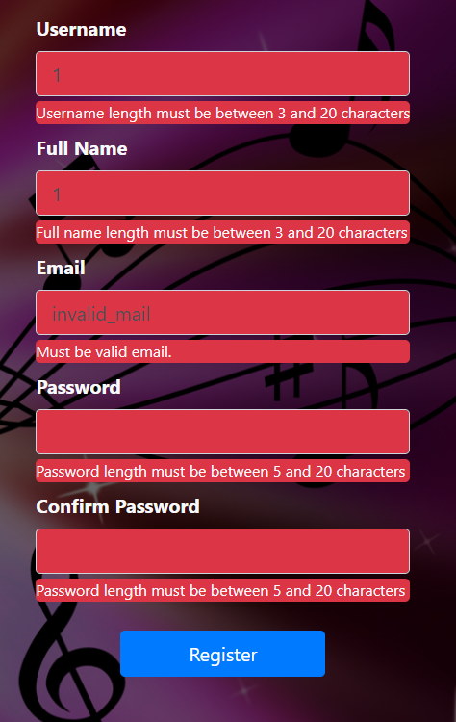

### Navigation (Guest user)

* Note: can access only to **Index**, **Login**, **Register** pages.



### Navigation (Registered user)

* Note: can access only to **Home**, **Add Album**, **Logout**.



### Add Album

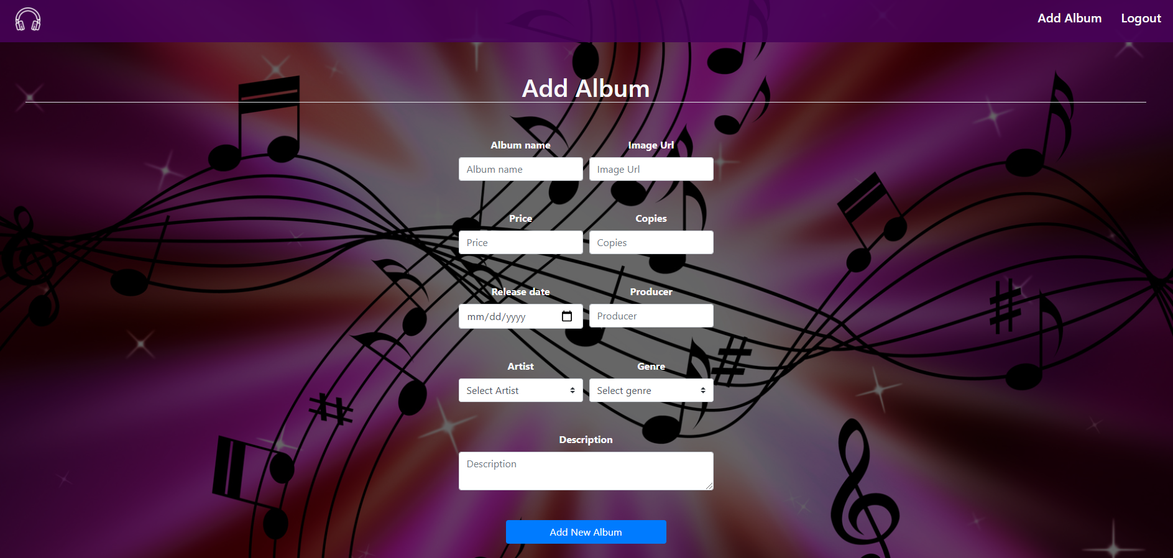

### Add Album validation

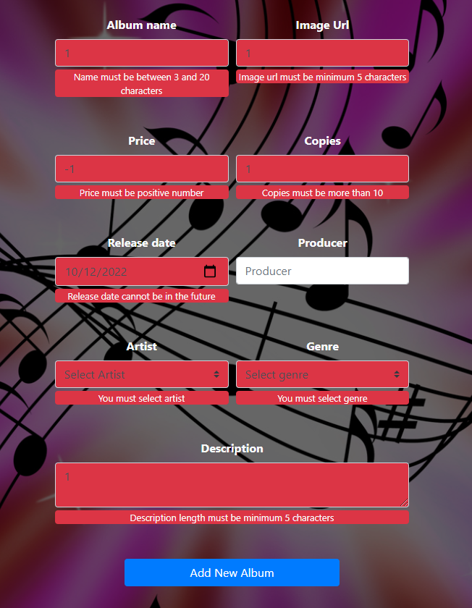

### Home Page (with albums)

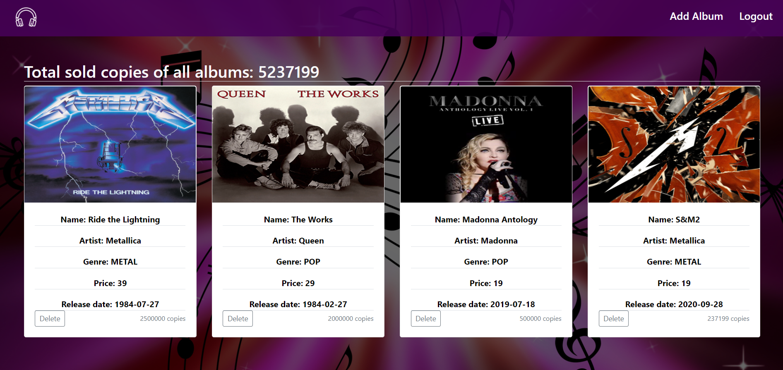

The templates have been given to you in the application skeleton, so make sure you implement the pages correctly.

**NOTE**: The templates should look **EXACTLY** as shown above.

**NOTE**: The templates do **NOT** **require** **additional** **CSS** for you to write. Only **bootstrap** and the **given css** are enough.

**NOTE:** Albums should be sorted based on the copies sold in **descending order**.

## Functional Requirements

The Functionality Requirements describe the functionality that the **Application** must support.

The **application** should provide Guest (not logged in) users with the functionality to login, register and **view** the Index page.

The **application** should provide Users (logged in) with the functionality to logout, **add an album**, **view all** Albums in DB (Home page) and **Delete a single one** from albums.

In **My Music DB Application**, the navbar should redirect to appropriate **URL depending** on that if the user is logged in.

The **application** should provide **functionality** for **adding albums** with **artist** and **category.** Also can delete them from the database.

Delete button remove the selected album from the database and again redirect to the home page

The first header on the home page shows the total sum of all copies of albums in the database at this moment.

The **application** should **store** its **data** into a MySQL database.

## Security Requirements

The Security Requirements are mainly access requirements. Configurations about which users can access specific functionalities and pages.

* Guest (not logged in) users can access Index page.
* Guest (not logged in) users can access Login page.
* Guest (not logged in) users can access Register page.
* Users (logged in) can access Home page.
* Users (logged in) can access Add Album page.
* Users (logged in) can access Logout functionality.

## Scoring

### Database – 10 points.

### Pages – 25 points.

### Functionality – 35 points.

### Security – 5 points.

### Validations – 15 points.

### Code Quality – 10 points.